# Frontend Mentor - QR code component solution

This is a solution to the [QR code component challenge on Frontend Mentor](https://www.frontendmentor.io/challenges/qr-code-component-iux_sIO_H). Frontend Mentor challenges help you improve your coding skills by building realistic projects.

### Screenshot

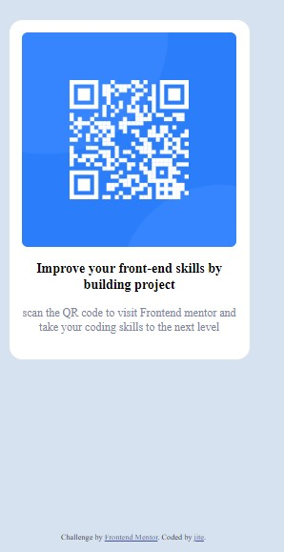

### Links

# Frontend Mentor - QR code component solution

This is a solution to the [QR code component challenge on Frontend Mentor](https://www.frontendmentor.io/challenges/qr-code-component-iux_sIO_H). Frontend Mentor challenges help you improve your coding skills by building realistic projects.

## Table of contents

- Overview

- Screenshot

- Links

- Author

-

### Screenshot

### Links

- Solution URL: [Add solution URL here](https://github.com/jite91/silver-octo-happiness/tree/main)

## Author

Challenge by [Frontend Mentor](https://www.frontendmentor.io/?ref=challenge" \t "http://127.0.0.1:5500/qr-code-component-main/_blank). Coded by [jite](http://127.0.0.1:5500/qr-code-component-main/index.html).